RIKKI-TIKKI-TAVI and LITERARY DEVICES
UNIT TEST
*****DO NOT WRITE ON THIS TEST*****
ABSOLUTELY NO TALKING

Fill in your gradecam ID# (the last five numbers of your student ID), your name, and class period. Once you have finished, please turn in all testing material to the designated area then silently read or work on other class work.

Good luck!!! Mrs. Jones

RL.7.4 - I can figure out the deeper meanings of words and phrases as they are used in a story.
RL.7.4 - I can identify several types of figurative language in a text.

- Identify the difference between a literary element and a literary technique.

- “Literary element” is the term used for all the devices in literature, including plot structure and word choice, whereas literary techniques are used to control how the audience reacts to a story.
- Literary elements are necessary in a story and provide plot structure, whereas literary techniques are word pattern choices made by the author.
- Literary elements are word pattern choices made by the author, whereas “literary technique” is the term used for all the devices in literature, including plot structure and word choice.
- Literary elements are word pattern choices made by the author, whereas literary techniques are necessary in a story and provide plot structure.

- Identify the type of literary technique used in the following passage:

“Teddy’s safer with that little beast than if he had a bloodhound to watch him. If a snake came into the nursery now – “

- Alliteration
- Personification
- Foreshadowing
- Repetition

- Identify the type of figurative language used in the following passage:

“It is the hardest thing in the world to frighten a mongoose, because he is eaten up from nose to tail with curiosity.”

- Simile
- Metaphor
- Idiom
- Personification

- Rikki-Tikki-Tavi’s name is an example of what type of figurative language?

- Personification
- Onomatopoeia
- Idiom
- Alliteration

- Read each passage carefully and compare the figurative language used in each. Examine each possible response closely, and identify which figurative language is used in each passage and what the difference is in how each uses comparison.

- “He could fluff up his tail till it looked like a bottle brush,”
- "Be careful. I am Death!"

- Passage 1 is a metaphor and 2 is a simile. “…like a bottle brush,” is a metaphor because it compares Rikki’s tail to a bottle brush using “like”, and “I am Death!” is a simile because it compares Karait to death by stating he “IS” death.
- Passage 1 is a simile and 2 is a metaphor. “…like a bottle brush,” is a simile because it compares Rikki’s tail to a bottle brush using “like”, and “I am Death!” is a metaphor because it compares Karait to death by stating he “IS” death.
- Passage 1 is an idiom and 2 is a metaphor. “…like a bottle brush,” is an idiom because it compares Rikki’s tail to a bottle brush using “like”, and “I am Death!” is a metaphor because it compares Karait to death by stating he “IS” death.
- Passage 1 is a simile and 2 is an idiom. “…like a bottle brush,” is a simile because it compares Rikki’s tail to a bottle brush using “like”, and “I am Death!” is an idiom because it compares Karait to death by stating he “IS” death.

- Given the fact that Rikki-tikki, Darzee, Darzee’s wife, Nag, Nagaina, and all the other animals in the story can speak, what type of figurative language is used most throughout the text?

- Hyperbole
- Personification
- Onomatopoeia
- Alliteration

7.1 - I can refer to the text to find several examples to support my thoughts and inferences about a story.

- What is the setting of the short story “Rikki-Tikki-Tavi”?

- Segowlee Cantonment, India, the garden of a bungalow owned by an English
- Middle-Eastern, pre-modern era, in the city of Agrabah
- Maine, 1957
- The rainforests of Africa in Segowlee Cantonment, a small hut owned by an English family

- Who is/are the protagonist(s) in the story?

- Rikki-Tikki-Tavi
- Nag and Nagaina
- Darzee and his wife
- Teddy and his family

- Who is/are the antagonist(s)?

- Rikki-TIkki-Tavi
- Nag and Nagania
- Darzee and his wife
- Teddy and his family

- Determine which of the following passages could be used to identify the setting?

- This is the story of the great war that Rikki-tikki-tavi fought single-handed, through the bath-rooms of the big bungalow in Segowlee cantonment. Darzee, the Tailorbird, helped him, and Chuchundra, the musk-rat, who never comes out into the middle of the floor, but always creeps round by the wall, gave him advice, but Rikki-tikki did the real fighting.
- They took him into the house, and a big man picked him up between his finger and thumb and said he was not dead but half choked. So they wrapped him in cotton wool, and warmed him over a little fire, and he opened his eyes and sneezed.
- One day, a high summer flood washed him out of the burrow where he lived with his father and mother, and carried him, kicking and clucking, down a roadside ditch. He found a little wisp of grass floating there, and clung to it till he lost his senses. When he revived, he was lying in the hot sun on the middle of a garden path, very draggled indeed, and a small boy was saying, "Here's a dead mongoose. Let's have a funeral."
- Then Rikki-Tikki went out into the garden to see what was to be seen. It was a large garden, only half cultivated, with bushes, as big as summer-houses, of Marshal Niel roses, lime and orange trees, clumps of bamboos, and thickets of high grass. Rikki-Tikki licked his lips. "This is a splendid hunting-ground," he said, and his tail grew bottle-brushy at the thought of it, and he scuttled up and down the garden, snuffing here and there till he heard very sorrowful voices in a thorn-bush.

- Passages 1 & 4 only
- Passages 2- 4 only
- Passages 1-3 only
- Passages 1-4 (all)

- Which of the following are supporting characters in the story? (Select ALL that apply – this is a multiple selection answer)

- Chuchundra
- Darzee & wife
- Karait
- Nag/Nagaina
- Rikki-Tikki-Tavi
- Teddy & Family

- Identify the situation (inciting incident) in the story.

- Rikki gets washed away from his home where he and his family live. He ends up in an English family’s garden, where he tries to protect the other animals and the family from the venomous snakes in the garden.
- Rikki becomes a legend and stays to keep the garden, the animals, and Teddy’s family safe.
- Rikki lures Nagaina away from Teddy with the last remaining snake egg, Nagaina and Rikki fight, and Rikki follows Nagaina into the snake hole.
- Teddy and his family are grateful to Rikki for protecting them.

- The following statement best describes which plot element:

Rikki lures Nagaina away from Teddy with the last remaining snake egg, Nagaina and Rikki fight, and Rikki follows Nagaina into the snake hole.

- Resolution
- Falling Action
- Exposition
- Climax

- Which 3 of the following are included in the rising action? (Select ALL that apply – this is a multiple selection answer)

- Darzee thinks Rikki is killed, sings his death song
- Rikki kills Karait (snakling) – Saves Teddy
- Rikki kills Nag in bathroom – Saves family
- Rikki meets Darzee and wife
- Rikki survives and kills Nagaina and egg
- Teddy and family are grateful to Rikki for protecting them

- What was the major conflict in the story?

- Rikki protecting Teddy in the nursery (Char v Char – Rikki v Karait)
- Rikki’s struggle to gain confidence (Char v Self)
- The cobras wanting to take over the garden and rid it of humans and animals (Char v Char - garden animals v cobras :: Rikki-Tikki v Nag/Nagania)
- Rikki realizing the cobra’s eggs are ready to hatch (Char v Nature)

7.2 - I can use details from the text to determine the theme or message of a story.

- Which passage supports the theme statement, “Good will triumph over evil”?

- “This is the story of the great war that Rikki-Tikki-Tavi fought single-handed, through the bath-rooms of the big bungalow in Segowlee cantonment.”

- “It is the hardest thing in the world to frighten a mongoose, because he is eaten up from nose to tail with curiosity. The motto of all the mongoose family is ‘Run and find out,’ and Rikki-tikki was a true mongoose.”

- All of the following are possible theme statements for the short story “Rikki-Tikki-Tavi” EXCEPT:

- Bravery, hard work, and loyalty pay off.
- Love is blind.
- Sometimes one must sacrifice themselves for the safety and sake of others.
- Good will triumph over evil.
RIKKI-TIKKI-TAVI and LITERARY DEVICES
UNIT TEST (key)

- B
- C
- C
- D
- B
- B
- A
- A
- B
- D
- A B C F
- A
- D
- B C D
- C
- A
- B

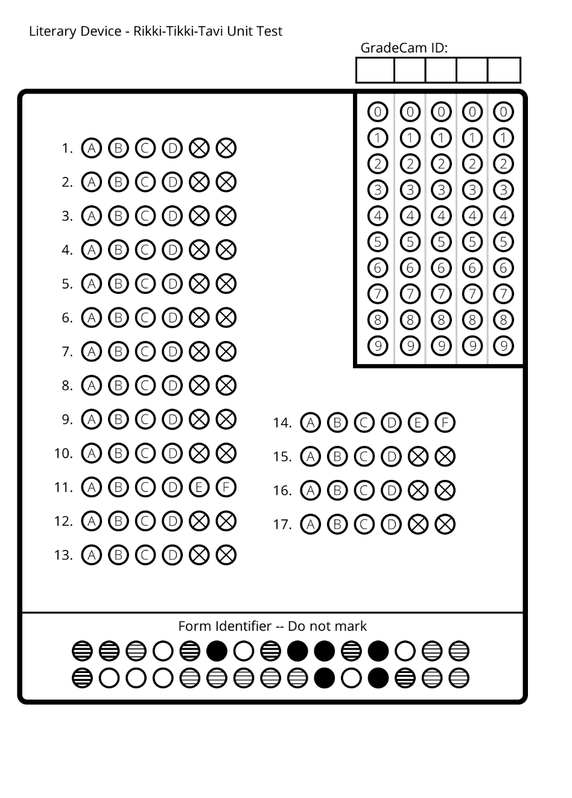
Name:_______________
Date:________________
Period:_______________
Name:_______________
Date:________________
Period:_______________

Name:_______________
Date:________________
Period:_______________
Name:_______________
Date:________________
Period:_______________
8945

Name:__________________________________ Period:_______

